PHASE -1
PROBLEM DEFINITION AND DESIGN THINKING

Date | 28 september 2023
Team id | GROUP 4
Project name | Fake news detection
Maximum mark

ABSTRACT :

Detecting fake news using machine learning techniques would mean having an automatic detection system that looks at a piece of text (tweets, news articles, a WhatsApp message) and determine how likely it looks like a piece of false news. The system will be a machine learning model trained on a large enough dataset containing examples of real and false news from various sources and styles. Machine learning models performing binary classification can be trained on this training set. However, since machine learning models only look at numerical features, we must perform natural language processing on this text corpus (collection of text samples).
Natural language processing will perform data cleaning, stemming, lemmatization, and vectorization using one of the many available techniques and convert sentences into a vector of numbers that machine learning models can interpret. Once this is done, we can train models like Naive Bayes, Logistic Regression, and Random Forests and observe their results.
If we find that the performance of these machine learning techniques is lacking in the dataset, we can delve into deep learning and look at LSTM or Attention-based models to perform text classification.
Fake news detection has a wide range of applications across various industries. Let us explore some real-world applications of false news detection-

Fake news spreads quickly on social media platforms, leading to misinformation and confusion. Many leading social media platforms have implemented false news detection algorithms to combat this issue. For example, Twitter uses machine learning to detect and flag potentially misleading or false information in tweets
News organizations use machine learning algorithms to verify information and sources. For example, the BBC developed a tool called "Project Origin," which uses natural language processing (NLP) and machine learning techniques to identify the origin of images and videos and determine if they are authentic or have been manipulated
Fake news can significantly impact political campaigns and elections. Several political organizations have developed tools to detect false news and misinformation. For example, the German political party CDU developed a tool called "Augmented Intelligence for Quality Journalism" (AIQ), which uses machine learning to identify and fact-check news articles.
Problem definition

- The phenomenon of Fake news is experiencing a rapid and growing progress with the evolution of the means of communication and Social media. Fake news detection is an emerging research area which is gaining big interest
It faces however some challenges due to the limited resources such as datasets and processing and analysing techniques. In this work, we propose a system for Fake news detection that uses machine learning techniques.

2) We used term frequency-inverse document frequency (TF-IDF) of bag of words and n-grams as feature extraction technique, and Support Vector Machine (SVM) as a classifier. We propose also a dataset of fake and true news to train the proposed system. Obtained results show the efficiency of the system.
In this work, we propose a system for Fake news detection that uses machine learning techniques. We used term frequency-inverse document frequency (TF-IDF) of bag of words and n-grams as feature extraction technique, and Support Vector Machine (SVM) as a classifier.

DESIGN THINKING

Design thinking is an extension of innovation that allows you to design solutions for end users with a single problem statement in mind. It not only imparts valuable skills but can help advance your career. It's also a collaborative endeavor that can only be mastered through practice with peers.

Empathy map:

An empathy map is a collaborative visualization used to articulate what we know about a particular type of user. It externalizes knowledge about users in order to
1) create a shared understanding of user needs,
2) aid in decision making. This article is a guide to empathy mapping and its uses.

Empathy map:
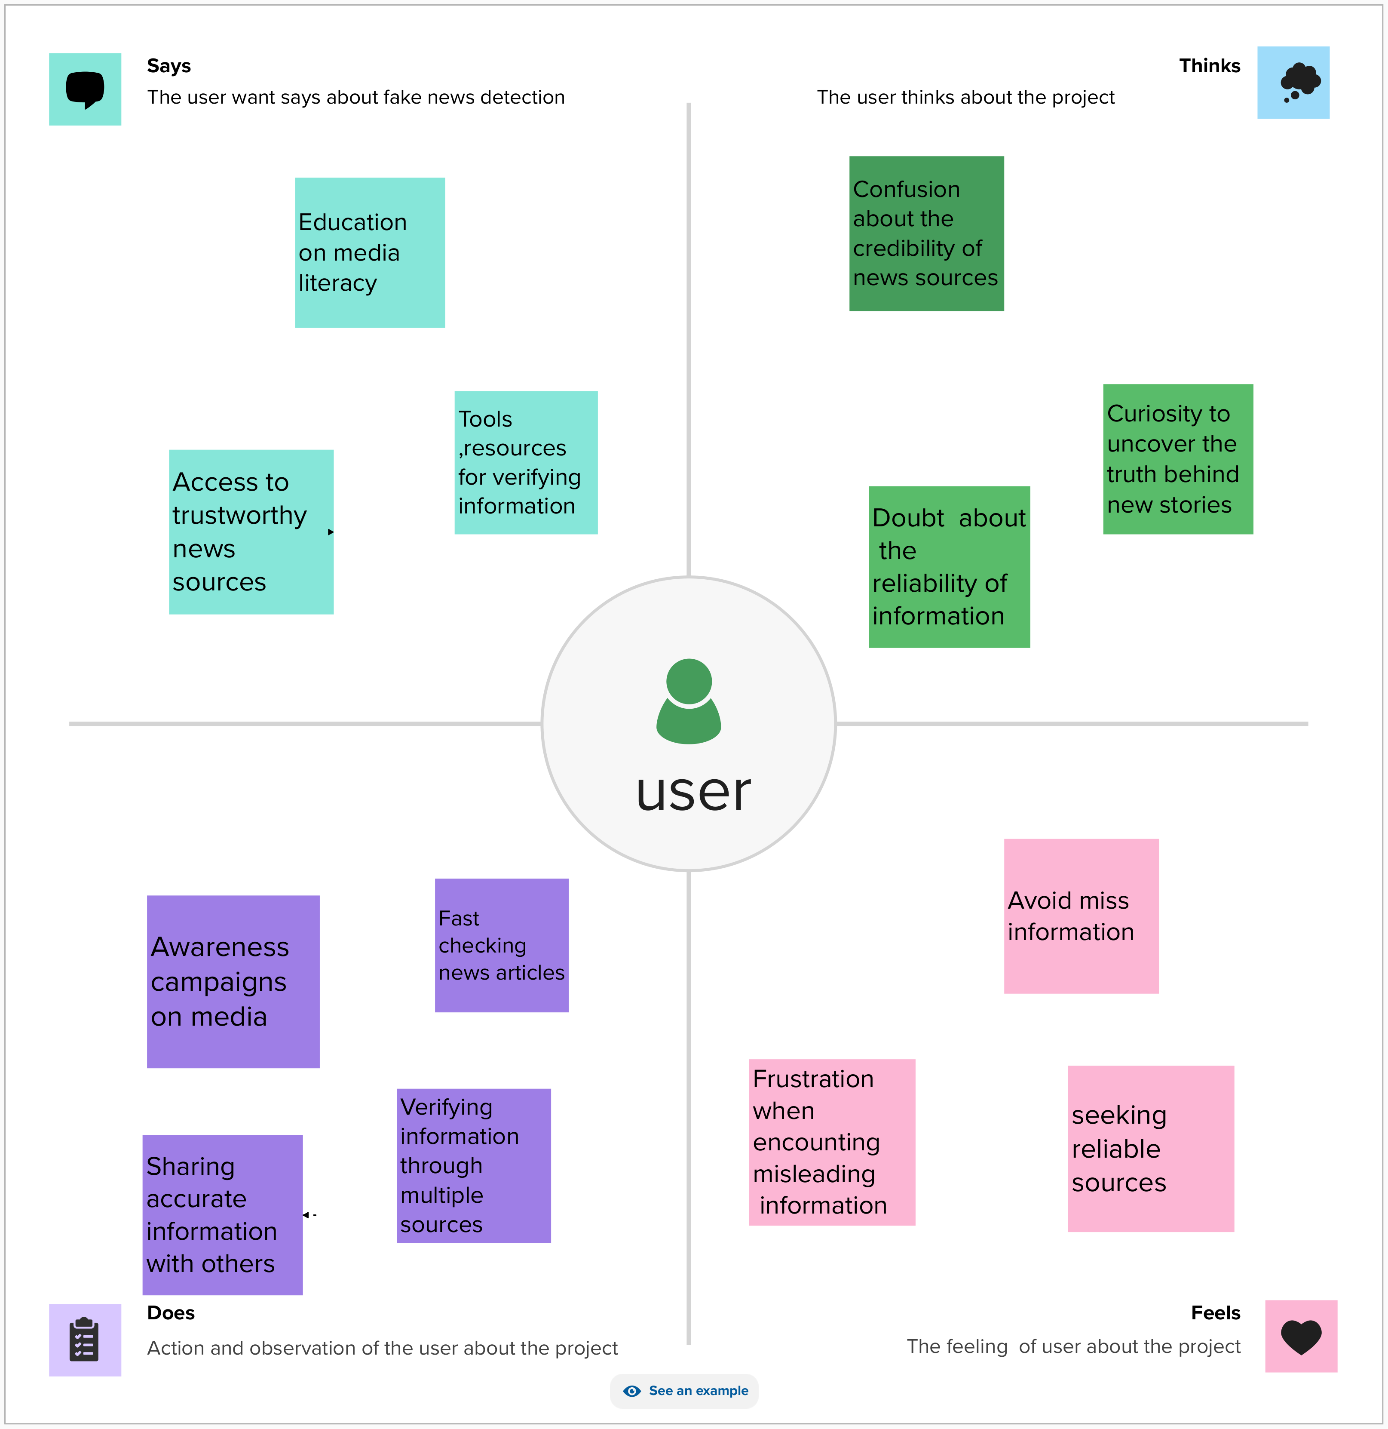

Brainstorm:
Brainstorming is a group problem-solving method that involves the spontaneous contribution of creative ideas and solutions. This technique requires intensive, freewheeling discussion in which every member of the group is encouraged to think aloud and suggest as many ideas as possible based on their diverse knowledge.

Brainstorm mapping:

Group ideas:

